**Assadullah**

**Bscs-5c**

**Reg # 122392**

**Introduction**: In this lab we learnt about the R language for data analysis. We installed R and Rstudio. Leant basic syntax and also we did analysis of data of mtcars.

**Assumption:**

A young person belonging to middle class family has range of 25 lac ) need a car having high following requirements

1. high speed (more displacement in low time)
2. low consuming fuel (low fuel)
3. low weight of the car
4. Having more number of gears
5. Powerfull engine (having more carbs)

**Analysis with graphs**

1. Cars with the values with graphs

barplot(mtcars$hp , main="displacement of the cars", xlab="cars", ylab="displacements")

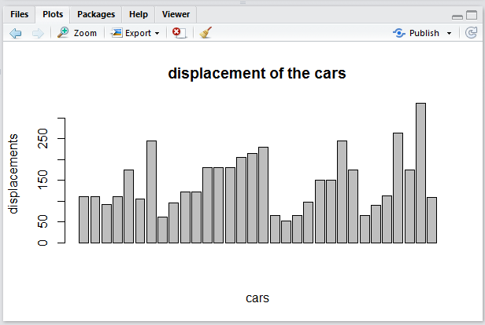

1. Graph comparision with mpg and the fuel consuming

barplot(mtcars$mpg ,mtcars$hp, main="horse power vs fuel onsumption", xlab="mpg", ylab="fuel")

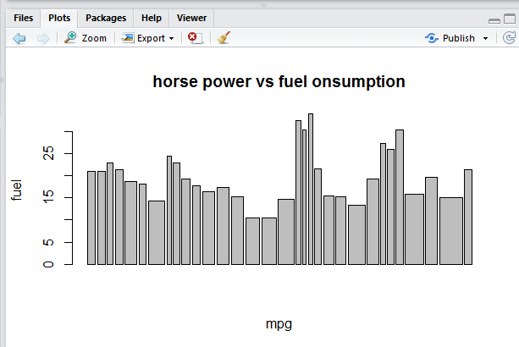

1. Displacement vs number of gears

barplot(mtcars$disp ,mtcars$gear, main="disp vs number of gears", xlab="disp", ylab="gears")

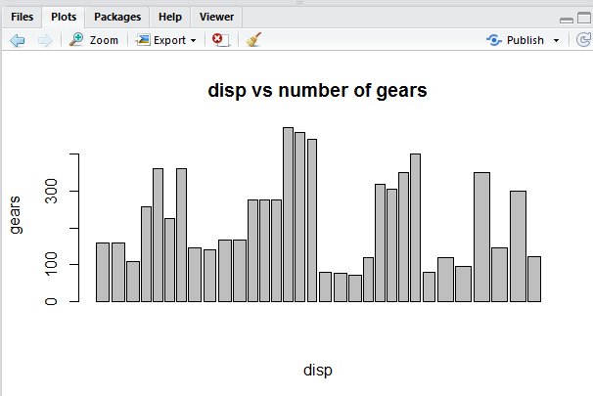

1. Horse power vs weight

barplot(mtcars$disp ,mtcars$wt, main="disp vs weight of the car", xlab="disp", ylab="weight")

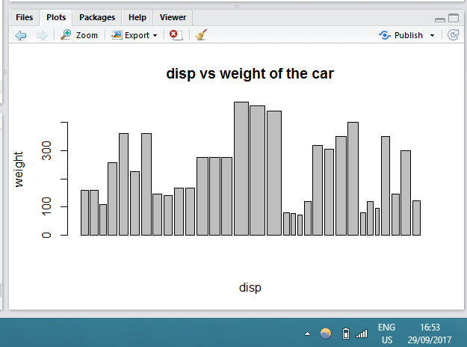

1. Comparision of disp, hp, wt, mpg

barplot(mtcars$disp ,mtcars$wt,mtcars$hp, mtcars$mpg, main="comparision of disp, hp, weight, mpg ", xlab="cars")

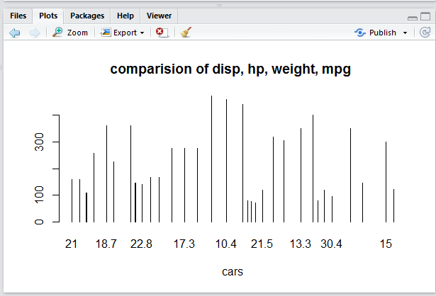

From above analysis the car which meet all the requirements for the user is Merc 450SLC